**Global Malnutrition Trends(1983-2019)**

**Introduction :**

ABC Company is undertaking an in-depth analysis of global malnutrition trends from 1983 to 2019 to better understand the prevalence and distribution of various forms of malnutrition among children under five years of age. Utilizing a comprehensive dataset from UNICEF/WHO/World Bank, the project aims to analyz severe wasting, wasting, stunting, underweight, and overweight conditions across different countries. By classifying countries according to their income levels (low, lower-middle, upper-middle, and high income) and other categories such as Least Developed Countries (LDC), Low Income Food Deficient (LIFD), Land Locked Developing Countries (LLDC), and Small Island Developing States (SIDS), the project seeks to uncover correlations between economic status and malnutrition rates. Through the use of advanced data visualization techniques in Power BI, including stacked bar charts and line charts, ABC Company aims to generate actionable insights that can guide policy-making and resource allocation to combat child malnutrition effectively. Malnutrition remains a critical global health issue, with children in lower-income countries disproportionately affected. ABC Company aims to address the challenge of identifying key patterns and trends in child malnutrition data over several decades. The primary problem is to determine how various forms of malnutrition correlate with economic and geographical classifications of countries, and to identify which countries and regions are most affected. By leveraging historical data, the project will highlight areas needing urgent attention and support, helping stakeholders to prioritize interventions and strategies for reducing malnutrition and its associated health risks among children under five. This analysis is crucial for developing targeted, data-driven solutions to improve child health outcomes worldwide.

Scenario 1: Count of U5 Population (140) This metric represents the number of observations related to the under-five population in the dataset. It indicates the sample size or the count of data points collected.

Scenario 2: Sum of Survey Sample (9M) The total sum of survey samples collected is 11 million. This large sample size adds robustness to the analysis and findings, ensuring that the insights derived are based on a substantial amount of data.

Scenario 3: Sum of Underweight (2.26K) The total number of underweight cases is 2,080. This highlights the prevalence of underweight conditions among children under five, which is a critical aspect of malnutrition to address.

**Technical Architecture:**

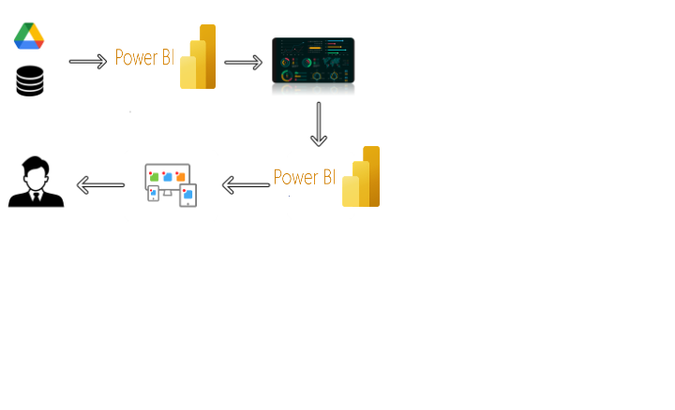

**Project Flow**

To accomplish this, we have to complete all the activities listed below,

* Data Collection & Extraction from Database
  + Collect the dataset,
  + Storing Data in DB
  + Perform SQL Operations
  + Connect DB with Power Bi
* Data Preparation
  + Prepare the Data for Visualization
* Data Visualizations
  + No of Unique Visualizations
* Dashboard
  + Responsive and Design of Dashboard
* Report
  + Responsive and Design of Dashboard
* Performance Testing
  + No of Visualizations/ Graphs
* Project Demonstration & Documentation
  + Record explanation Video for project end to end solution
  + Project Documentation-Step by step project development procedure

**Milestone 1: Data Collection & Extraction from Database**

Data collection is the process of gathering and measuring information on variables of interest, in an established systematic fashion that enables one to answer stated research questions, test hypotheses, and evaluate outcomes and generate insights from the data.

**Activity 1: Collect the dataset**

Please use the link to download the dataset: [Link](https://www.kaggle.com/datasets/ruchi798/malnutrition-across-the-globe?select=malnutrition-estimates.csv)

Activity 1.1: Understand the data

Data contains all the meta information regarding the columns described in the CSV files

Column Description of the Dataset:

* ISO code: Standardized two-letter country codes.
* Country: Name of the country.
* Survey Year: The year in which the survey data was collected.
* Year: The specific year of the data point.
* Income Classification: Income classification of countries (0: Low Income, 1: Lower Middle Income, 2: Upper Middle Income, 3: High Income).
* LDC: Indicator for Least Developed Countries (LDCs).
* LIFD: Indicator for Low Income Food Deficient (LIFD) countries.
* LLDC or SID2: Classification for Land Locked Developing Countries (1), Small Island Developing States (2), and Others (0).
* Survey Sample (N): The size of the survey sample.
* Severe Wasting: Average percentage of children with severe wasting.
* Wasting: Average percentage of children with wasting.
* Overweight: Average percentage of overweight children.
* Stunting: Average percentage of children with stunting.
* Underweight: Average percentage of underweight children.
* U5 Population ('000s): Population of children under five years old (in thousands).

**Activity 2: Connect Data with Power BI**

With Power BI, users can seamlessly connect to a wide range of data sources, including databases, cloud services, spreadsheets, and streaming data. This capability allows organizations to consolidate disparate data sources into a single, unified platform, breaking down data silos and enabling holistic analysis.

**Milestone 2: Data Preparation**

Preparing the data for visualization involves cleaning the data to remove irrelevant or missing data, transforming the data into a format that can be easily visualized, exploring the data to identify patterns and trends, filtering the data to focus on specific subsets of data, preparing the data for visualization software, and ensuring the data is accurate and complete. This process helps to make the data easily understandable and ready for creating visualizations to gain insights into the performance and efficiency. Since the data is already cleaned, we can move to visualization.

3.1: Data Loading :

[Link](https://drive.google.com/file/d/1iLQTWdG0chi6S9gUAvA0-7D6p8w1AYgO/view?usp=drive_link)

3.2 Data Cleaning:

[Link](https://drive.google.com/file/d/10tD0YoSkfWKD3ZiGwkzF3qF1DevuliJ6/view?usp=sharing)

**Milestone 3: Data Visualization**

Data visualization is the process of creating graphical representations of data in order to help people understand and explore the information. The goal of data visualization is to make complex data sets more accessible, intuitive, and easier to interpret. By using visual elements such as charts, graphs, and maps, data visualizations can help people quickly identify patterns, trends, and outliers in the data.

**Activity 1.1: Count of U5 Population**

The number of unique visualizations that can be created with a given dataset.

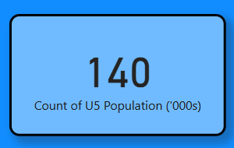

**Activity 1.2:Sum of Survey Sample**

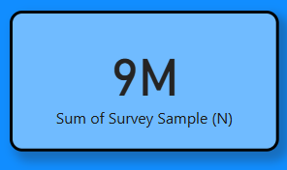

**Activity 1.3:Sum of Underweight**

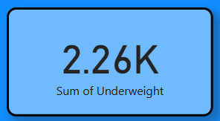

**Activity 1.4: Sum of LDC,LIFD,LLDC or SID2 and Average of Stunting by Income Analysis**

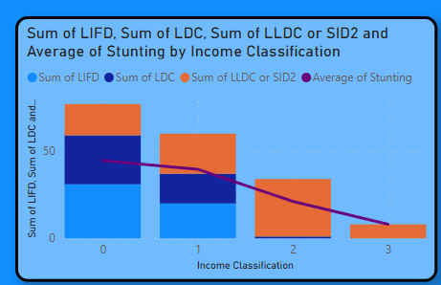

**Activity 1.5: Sum of Overweight and Underweight under Income Classification.**

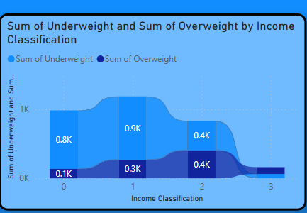

**Activity 1.6: Sum of Overweight by Country**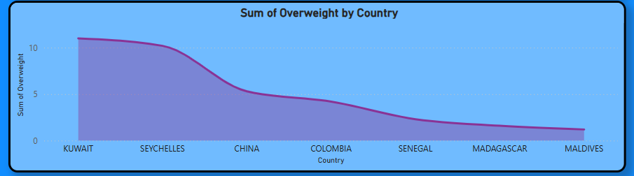

**Activity 1.7: Sum of Income Classification**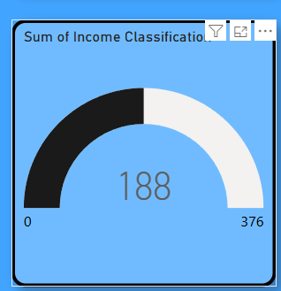

**Milestone 4: Dashboard**

A dashboard is a graphical user interface (GUI) that displays information and data in an organized, easy-to-read format. Dashboards are often used to provide real-time monitoring and analysis of data, and are typically designed for a specific purpose or use case. Dashboards can be used in a variety of settings, such as business, finance, manufacturing, healthcare, and many other industries. They can be used to track key performance indicators (KPIs), monitor performance metrics, and display data in the form of charts, graphs, and tables.

**Activity :1- Responsive and Design of Dashboard**

The responsiveness and design of a dashboard for Social Pulse Illuminating the Digital Footprint Unveiling Social Media Engagement Is crucial to ensure that the information is easily understandable and actionable. Key considerations for designing a responsive and effective dashboard include user-centred design, clear and concise information, interactivity, data-driven approach, accessibility, customization, and security. The goal is to create a dashboard that is user-friendly, interactive, and data-driven, providing actionable insights to improve the performance and efficiency of Social Pulse Illuminating the Digital Footprint Unveiling Social Media Engagement.

Once you have created views on different sheets in Power Bi you can pull them into a dashboard.

Dashboard 1 :

Explanation video link: <https://drive.google.com/drive/folders/136tiyOcX9LOJbbYRIHwA9kqpJSYbbqTU?usp=sharing>

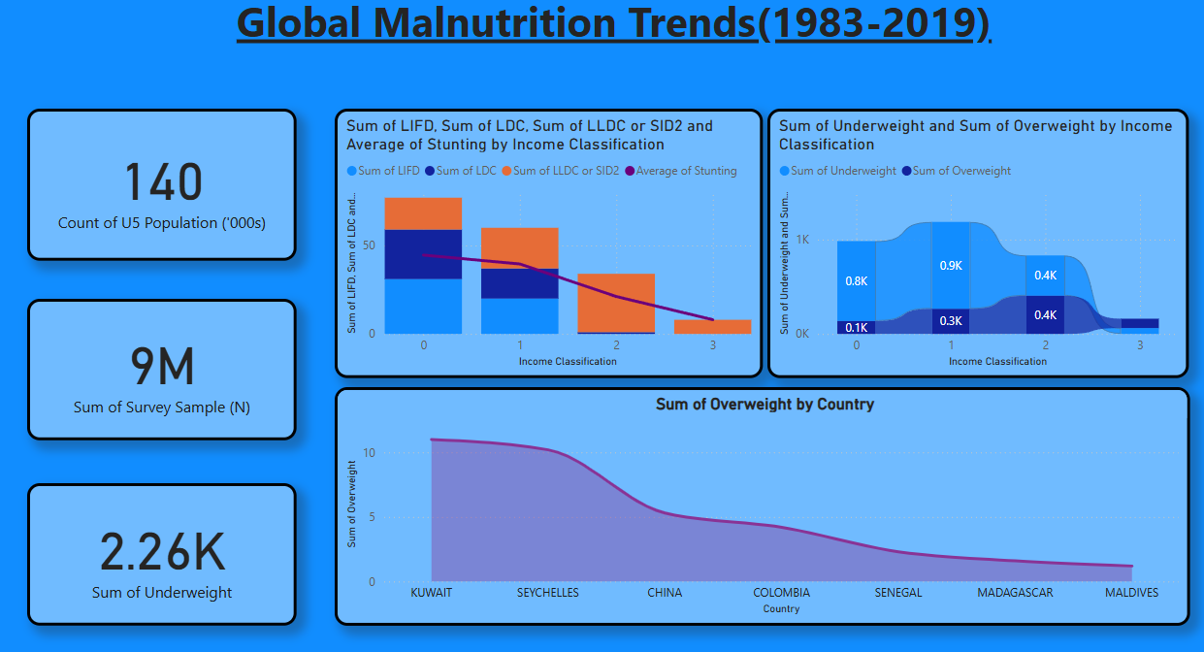

**Milestone 5: Report**

A data report is a way of presenting data and analysis in a narrative format, with the goal of making the information more engaging and easier to understand. A data story typically includes a clear introduction that sets the stage and explains the context for the data, a body that presents the data and analysis in a logical and systematic way, and a conclusion that summarizes the key findings and highlights their implications. Data Report can be told using a variety of mediums, presentations, interactive visualizations, and videos.

**Report 1:**

**Explanation video link:**

<https://drive.google.com/drive/folders/136tiyOcX9LOJbbYRIHwA9kqpJSYbbqTU?usp=sharing>

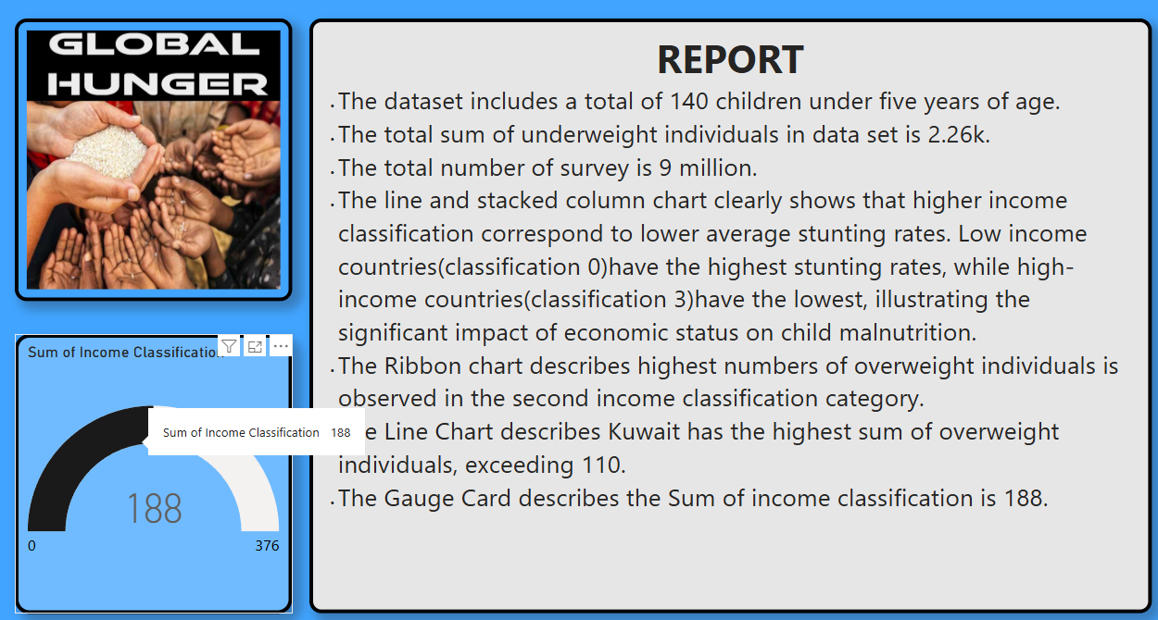

**Milestone 6: Performance Testing**

Performance testing is a crucial aspect of software development aimed at evaluating the speed, responsiveness, stability, and scalability of an application under various workload conditions. It involves simulating real-world usage scenarios to assess how the system behaves and performs under stress, peak loads, or normal conditions.

**Activity 1: Utilization of Data Filters**

The utilization of data filters plays a pivotal role in streamlining information processing and analysis across various domains. By selectively extracting or excluding specific data points based on predefined criteria, filters enable efficient data management and enhance decision-making processes.

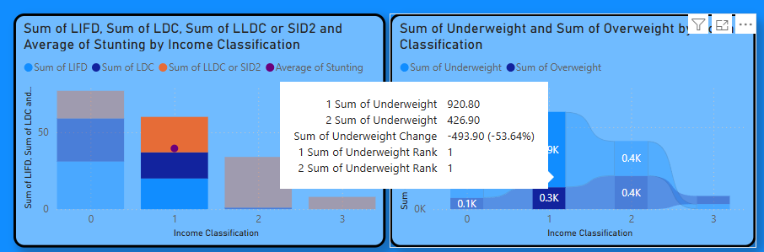

**Activity 2 : No of Visualizations/ Graphs**

1. **Count of U5 Population**
2. **Sum of Survey Sample(N)**
3. **Sum of Underweight**
4. **Sum of Overweight by Country**
5. **Total Income Classification**
6. **Sum of Overweight and Underweight by Income Classification**
7. **Sum of LDC, LIFD, LLDC or SID2 and Average of  Stunting by Income Analysis**

**Milestone 7: Project Demonstration & Documentation**

Below mentioned deliverables to be submitted along with other deliverables

**Activity 1:- Record explanation Video for project end to end solution**

Creating a record explanation video for a project's end-to-end solution is crucial for ensuring clarity and transparency in its implementation. This video serves as a comprehensive guide, detailing every aspect of the project from inception to completion.

**Activity 2:- Project Documentation-Step by step project development procedure**

Create document as per the template provided